**KickStarter Project Analysis**

**Introduction**

Over two billion dollars have been raised using the massively successful crowdfunding service, Kickstarter, but not every project has found success. Of the over 300,000 projects launched on Kickstarter, only a third have made it through the funding process with a positive outcome.

We are looking to organize and analyze a database of four thousand past projects in order to uncover any hidden trends.

**Data:**

Organized and obtained from the Datasheet below. Provided outside of this document if using PDF format of report.



**Method**

With a use of Microsoft Excel with features like Pivot Table, Pivot Charts, Conditional Formatting and Mathematical and Logical Functions.

**Analysis**

The first set of Pivot Table and Chart below, represents the ‘Category’ and the ‘state’ and lists the count of the ‘successful’, ’failed’, ’canceled’ and ‘live’ projects, filtered by ‘Country’. Provides the ‘Grand Total’ of all the projects.

Table 1:

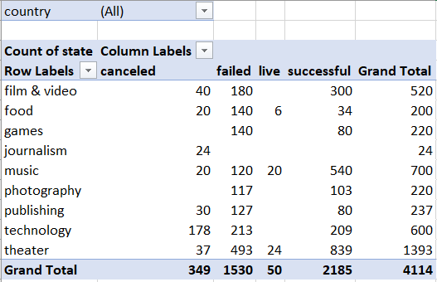

Chart 1:

Above chart provides the Stacked Column representing the ‘Category’ in X-axis and count of ‘State’ in Y-axis.

The second set of Pivot Table and Chart below, represents the ‘Sub-Category’ and the ‘state’ and lists the count of the ‘successful’, ’failed’, ’canceled’ and ‘live’ projects, filtered by ‘Country’ and ‘Category’. Provides the ‘Grand Total’ of all the projects.

Table 2:

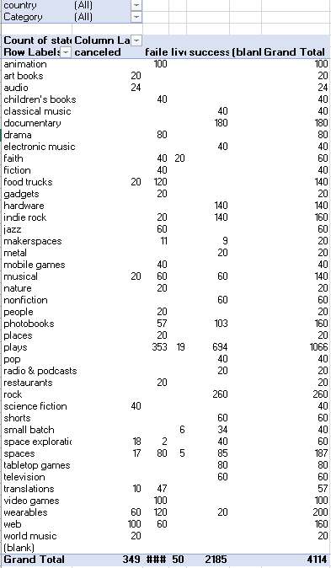

Chart 2:

Above chart provides the Stacked Column representing the ‘Sub-Category’ in X-axis and count of Project ‘State’ in Y-axis.

The third set of Pivot Table and Chart below, represents the Month of project initiation again the count of column ‘State’ and determines the ‘successful’, ’failed’, ’live’ and ‘canceled’ projects. It can be filtered with ‘Category’ and ‘Year’ of initiation.

Table 3:

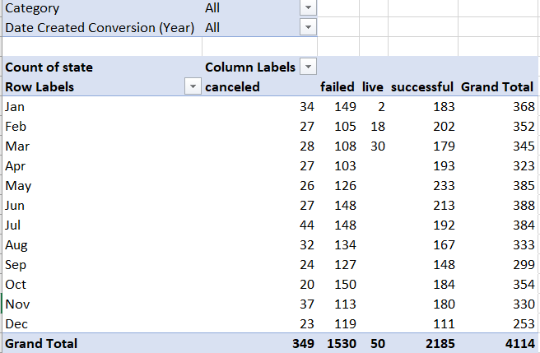

Chart 3:

Above chart provides the Line Chart representing the ‘Month’ in X-axis and count of Project ‘State’ in Y-axis.

The fourth set of Table and Chart below, represents the count of the ‘Successful’, ‘Failed’ and ‘Canceled’ state of the projects which are listed under various groups based on the goal amount for each. Percentages are calculated for each.

Table 4:

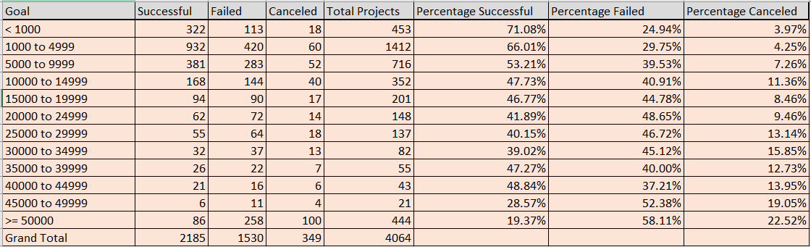

Chart 4:

Above graph depicts the percentages of ‘Successful’, ‘Failed’ and ‘Canceled’ projects based on the goal amount decided by the Kickstarters.

**Results:**

* Most successful projects are for the Category of ‘Theater’, followed by ‘Music’ and ‘Film&Videos’.
* Most of the canceled projects are in category ‘Technology’.
* Most successful projects are for the Sub-Category of ‘Play’, followed by ‘Rock’ and ‘Documentary’.
* Most of the canceled projects are in Sub-category ‘Web’ and ‘Wearables’.
* A lot of crowdfunding projects are initiated during early Spring to mid-Summer.
* During the month of May, a lot of projects have seen Success.
* In general, the count of successful projects is more than failed ones most time of the year. But, in the month of December, one can see the volume of failed projects are more than the successful projects.
* Year 2009 saw a lot of success. While year 2010 saw dramatic up’s and down’s for the Kickstarters. 2011 and 2013 were pretty good period for most projects. 2014 was a dramatic shift with lots of failure noticed all across the year. Since then there is no consistency in the success rate of projects. Percentages of successful projects have be moderately better than failed set.
* As the goal amount goes higher, the count of successful projects are reduced.
* Based on each country, the success and failure categories are widely different.

**Conclusion(s):**

* Data suggests, people are likely to find success in category of ‘Theater’ and Music. Specifically, sub-category of ‘Play’ and ‘Rock’ music.
* Data indicates, the least likely projects to succeed are for category of ‘Technology’ and sub-Category of ‘Web’ and ‘Wearables’. Most likely Kickstarters cancel these projects before the goal is met.
* Based on the graphs and analysis, the best time to initiate crowdfunding are during Spring and Summer when most people are enthusiastic of investing and venturing into many new projects.
* Line chart indicates that people prefer to invest smaller amounts and look for projects with goal amount within 15000.
* While Theater and Music are primary preference in USA, as it moves to Europe, the preference are changed to Technology and Wearables. Crowdfunding is least popular in the East. China and Australia are less invested in Kickstart projects.

**Limitations:**

The Data available is limited to year and geography. There is more scope to analyze if we have data of people who pledge money and contribute. Their age details and the occupational background is good indicators of trends.

Cancelation reasons are not given in the datasheet. They add more depth to the analysis.

**Suggestion/Improvement possibilities:**

Line chart of ‘Goal’ amount and the ‘State’ column percentage can be plotted by filtering on each country to better understand the risk appetite of people.

Chandler,AZ

02-28-2019